**VidiaPrint API Documentation**

1. Login

Url : <https://api.vidiaprint.com/upload/token>

Method : POST

Parameter :

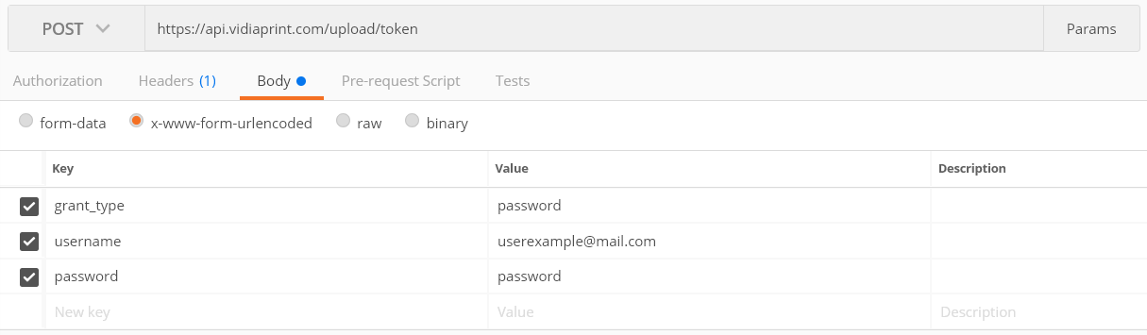

Response (200 OK):

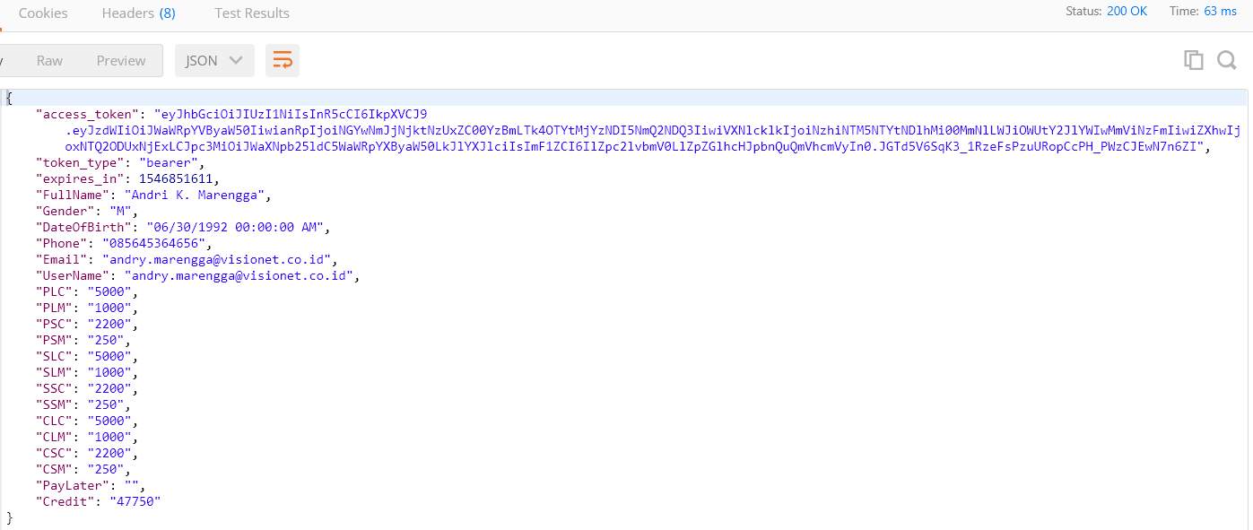

Response Failed (400 Bad Request):

* Username/Password Incorrect

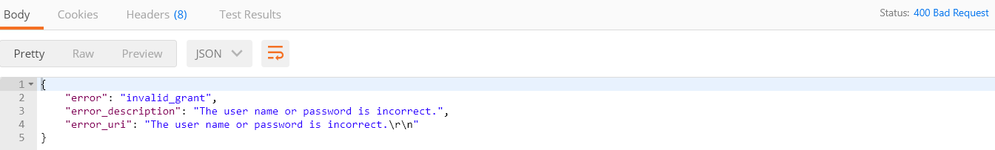

* Username is not registered

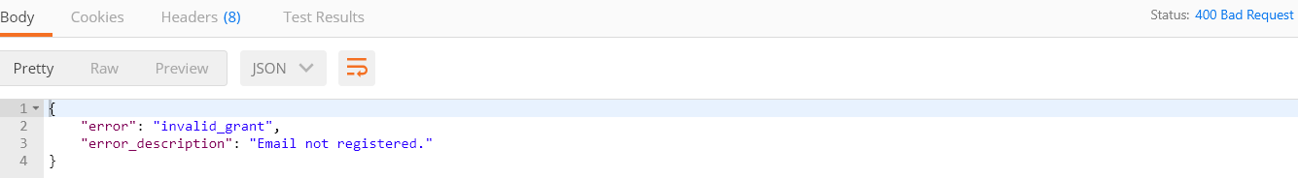

1. Register

Url : <https://api.vidiaprint.com/upload/api/account/register>

Method : POST

Parameter :

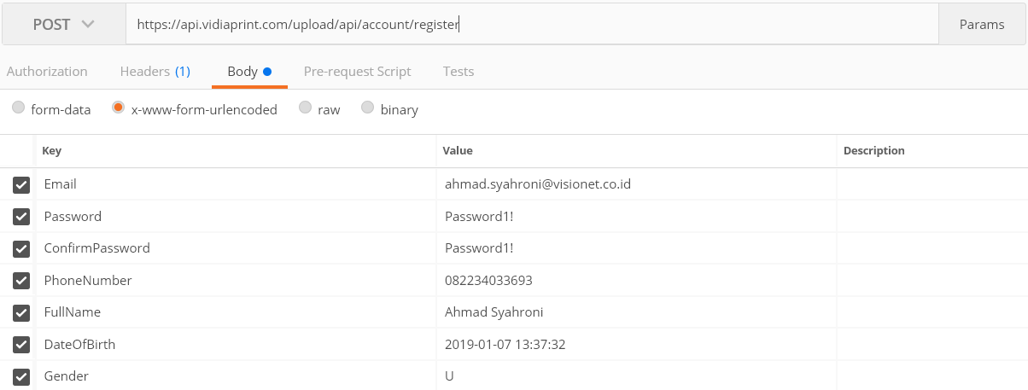

Response Success (200 OK)

Response Failed (400 Bad Request/500 Internal Server Error)

Response Invalid Token (401 Unauthorized)

1. Upload File

Url : <https://api.vidiaprint.com/upload/api/userfiles>

Method : POST

Header :

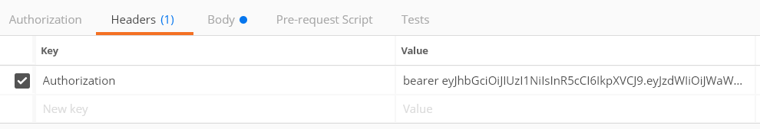

Parameter :

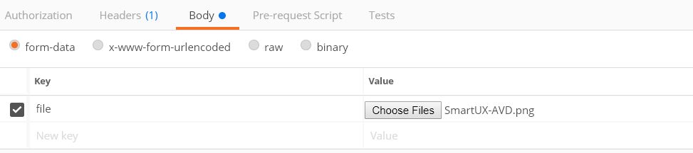

Response Success (200 OK) :

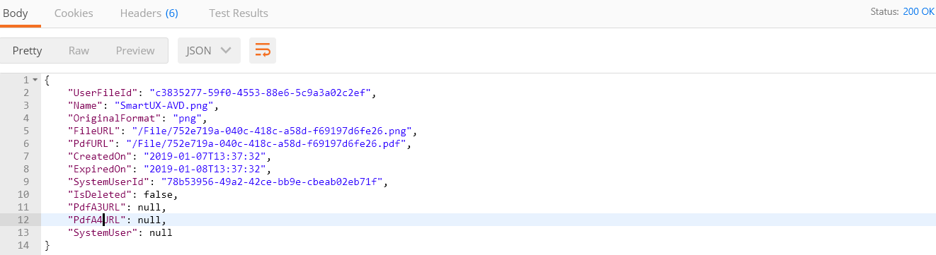

Response Invalid Token (401 Unauthorized)

1. Delete File

Url : <https://api.vidiaprint.com/upload/api/userfiles>/{id}

Method : DELETE

Header :



Response Success (200 OK)

Response Invalid Token (401 Unauthorized)

1. Get List File

Url : <https://api.vidiaprint.com/upload/api/userfiles>/{id}

Method : GET

Header :



Response Success (200 OK)

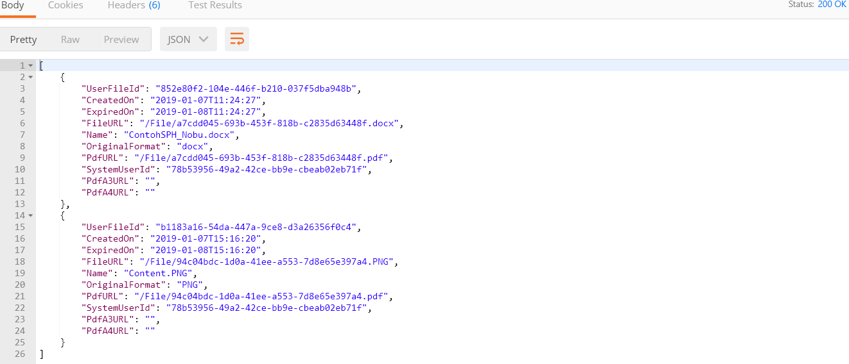

Response Invalid Token (401 Unauthorized)

1. Get List Transaction

Url : <https://api.vidiaprint.com/upload/api/transactions>

Method : GET

Header :



Response Success (200 OK)

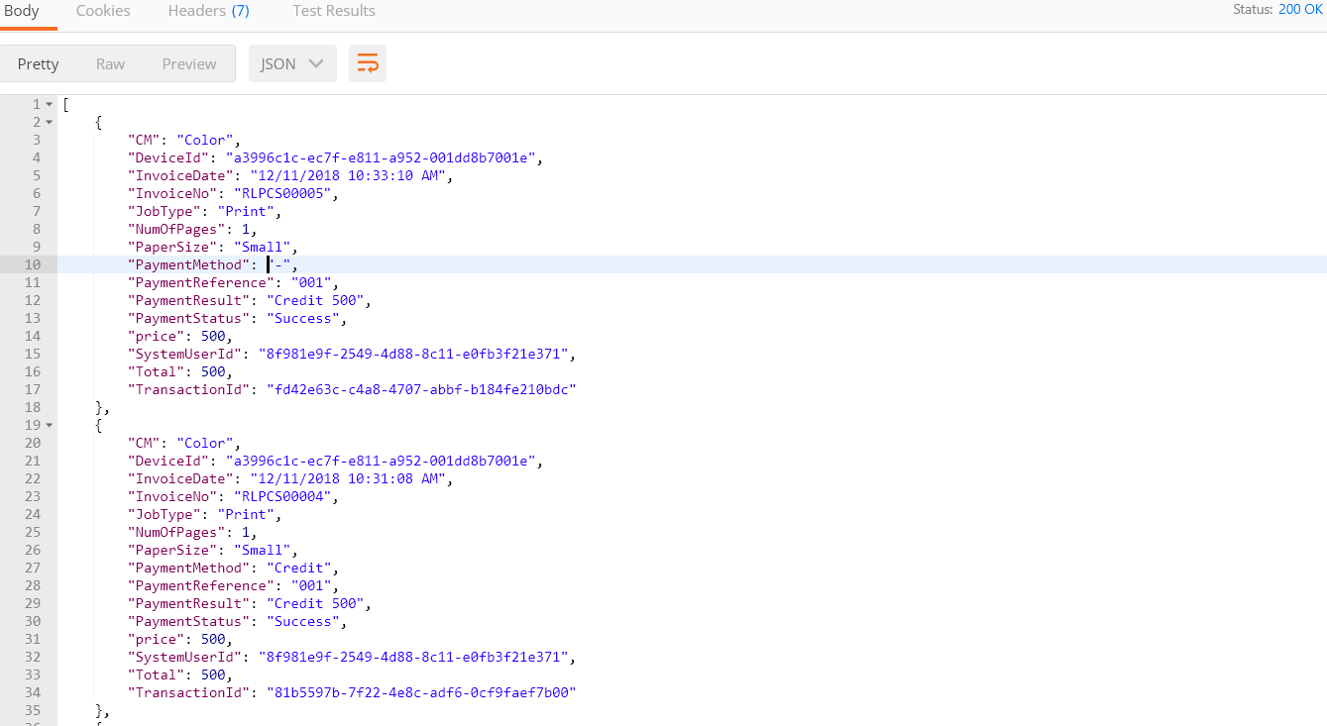

Response Success No Data (200 OK)



Response Invalid Token (401 Unauthorized)